Monroe County Health Center  The Monroe County Health Center is excited to offer a variety of workshops and training events.  Workshops include:  - coping with chronic illness  - infant and adult CPR  Training will also be held for the following:  *food handlers card  * community Emergency Response Team (CERT)  Learn to deal with chronic pain and illness, how to respond to community emergencies, first aid and CPR  Call 304-753-6960 to join us!  __________________  Monroe County School Nurse  Contact Allison St.Clair at  304-772-3094 for training information on the following:  - Teen Issues Day  - CPR and AED’s in the schools  - Blood Mobile |  | Monroe County Resident  Monroe County, WV | Monroe County Community Resources  - Are you looking for health care, training, medical assistance or dental assistance? Look no further! Monroe County West Virginia and surrounding counties may be able to assist you. Look inside to see what we have to offer.  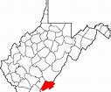

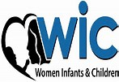  West Virginia WIC  Located in Lindside, WV, WIC is an agency designed to assist women, infants and children. From low income housing assistance, food stamp assistance, medical and dental and nutritional programs, WIC may be able to assist you.  The agency offers a variety of training opportunities from basic first aid, filling out applications, infant and adult CPR, to how to secure medical and dental assistance.  Contact the Lindside WIC office at 304-753-5582. | 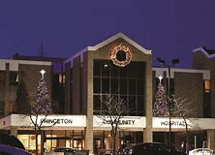  Princeton Community Hospital is located in the neighboring county of Mercer County. In addition to emergency department care, hospitalization and outpatient care, Princeton Community Hospital offers childbirth classes, breastfeeding classes, diabetic education, CPR courses and hosts the Women’s Expo, focusing on women’s health.  Classes are designed to offer childbirth options, diabetic care and menu planning, infant care and life saving techniques  To sign up for classes, contact Princeton Community Hospital at 304-487-7000 | Peterstown Fire and Rescue  Don’t be shy! Show the community how fabulous you are and learn how to be a help to your community with first aid, lifesaving techniques, job and volunteer opportunities.  Department classes offered:  - basic first aid  - CPR  - fire and rescue courses  - EMT classes  Contact Us  Peterstown Fire and Rescue  Boomer Brown, President  304-753-4343  